DHT11

Overview：

The purpose of this course will use the arduino control temperature and humidity sensor DHT11 to test the temperature and humidity values in the environment.

Materials：
Arduino Uno x 1
DHT11 x 1
DuPont wires x 3

Product description :
The DHT11 digital temperature and humidity sensor is a temperature and humidity composite sensor with the output of calibrated digital signals.
It uses dedicated digital module acquisition technology and temperature and humidity sensing technology to ensure product have high reliability and excellent long-term stability. The sensor includes a Resistance humidity sensor and an NTC temperature measuring element.

Technical Parameters ：
◆Working voltage: 5VDC/3.3VDC.
◆Humidity measurement range: 20%~90%RH.
◆Measurement accuracy: ±5%RH.
◆Temperature measurement range: 0 ~ 50 ℃
◆Temperature measuring accuracy: ±2 ℃
◆Digital signal output
◆The data port is equipped with a pull resistor.
◆It is equipped with 3mm fixed screw hole for easy installation.

Wiring diagram:
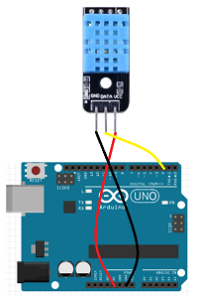

Example code:
#include <dht11.h>

dht11 DHT11;
#define PIN_DHT11 2

void setup()
{
Serial.begin(9600);
}

void loop()
{
DHT11.read(PIN_DHT11);
Serial.print("Humidity (%): ");
Serial.println((float)DHT11.humidity, 2);
Serial.print("Temperature (oC): ");
Serial.println((float)DHT11.temperature, 2);
delay(500);
}

Experimental phenomena：
After the code runs, the current temperature and humidity will be printed in the of the arduino.

